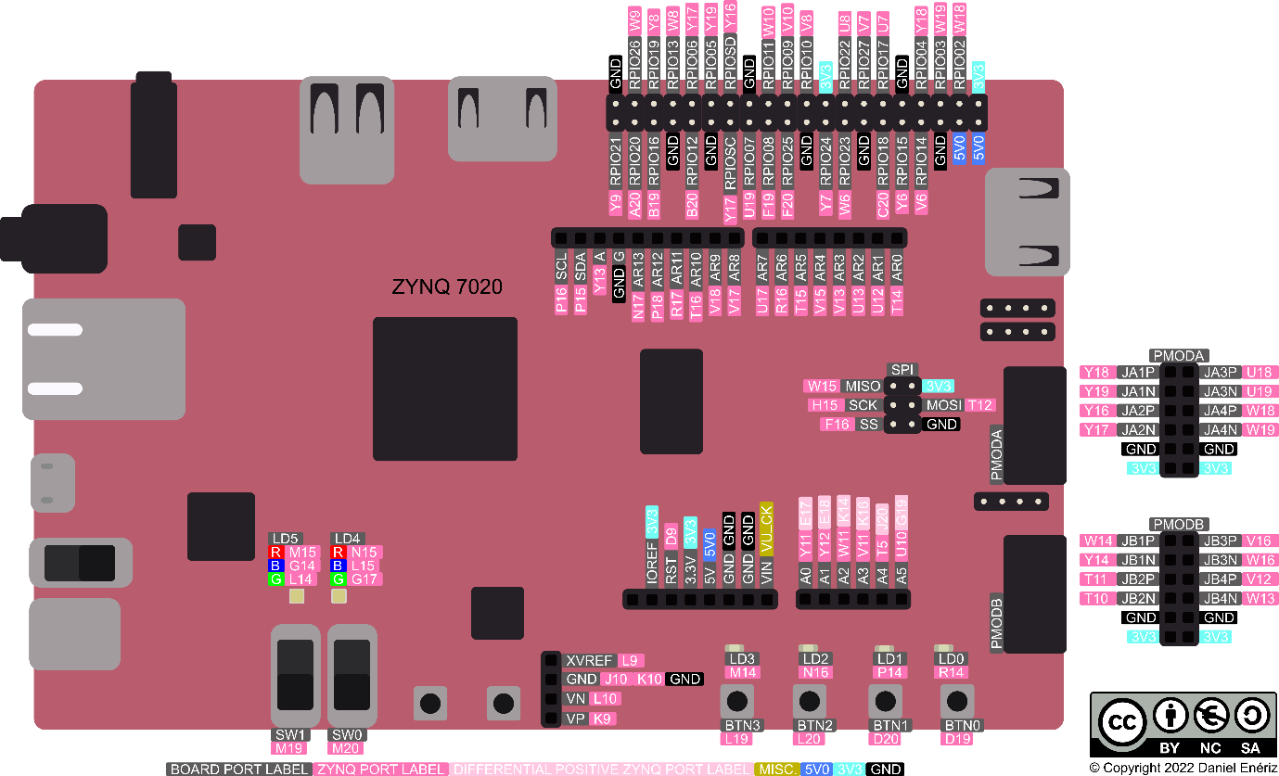

Type of Ports | Number of Pins | Pin Usecase | Others
Pmod – A and Pmod -B | Total 24 pins (12 each) | Pin – 6, 12 Vcc  Pin – 5, 11 Gnd  Pin – 1 to 4 and 7 to 10 Logic signal pins
HDMI pins | X2 | Input, Output
Micro USB | X1 | UART (Both input and output) | Supports USB-Jtag, USB-UART
USB | X1 | 8-bit ULPI interface | Speeds upto 480Mbs
Arduino shield Digital I/O | J3 pins – x10  J4 pins – x8  J7pins – x8  SPI pins – x6 | J3 pins (AR8 – AR13 and A) I/O pins  J3 pins (AR_SDA, AR_SCL) SDA, ACL  J4 pins (AR0 – AR7) I/O pins  J7 pins (VU_CK, 5v5, 3v3, GND) Power and ground  J7 pins (AR_RST) RST  SPI pins (AR_MISO, AR_SCK, AR_SS, AR_MOSI) MISO, SCK, SS, MOSI
Arduino shield Analog I/O | J1 pins - x6 | J1 pins - A0 to A5 (I/O pins)
Raspberry GPIO | Pins – x40 | GND – 1,6,9,14,20, 25,30,34,39  Power – 2 (5 volts), 4 (5volts), 17(3 volts)  Zynq pins – 3,5,7,8,10,11,12,13,15,16,17,18,19,21,  22,23,24,26,27,28,29,31,32,33,35,36,37,38,40

- HDMi input & output pins can be configured according the usecase of the users, i.e HDMi input can also be used as an output pin and vice versa.
- Pynq can also be powered from the micro USB port.
- The USB interface is configured to act as an embedded host. USB OTG and USB device modes are not supported.

